📘 CHAPTER 2: VM PLATFORM, DATA CONVERSIONS & BOOLEAN LOGIC
🔻 Why Low-Level Knowledge Matters (Especially for C/C++ Devs)
If you're serious about becoming a C or C++ developer, you can’t ignore what’s happening under the hood. These languages give you power and control — but also more chances to shoot yourself in the foot if you don’t understand memory, instructions, or the system architecture.
🧠 High-level languages hide a lot from you.
💥 C/C++ forces you to face reality — memory, pointers, addresses, machine code.
When bugs happen in C or C++, they often don’t show up clearly at the source code level. You may need to “drill down” into the:
- CPU registers
- Raw memory
- Instruction-level behavior
That’s where tools like assemblers, linkers, and debuggers come in.

🛠️ Core Tools of the Low-Level World
1️) Assembler — Translating Assembly to Machine Code
An assembler takes your assembly language code and converts it into machine code — the binary stuff the CPU can actually execute.
- Input: .asm or .s file (your code)
- Output: .obj or .o file (machine-readable object code)
Example:
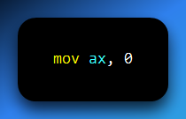

Assembler turns this into something like:
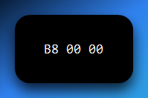
Assemblers are like compilers, but for assembly. They don’t optimize — they just translate.
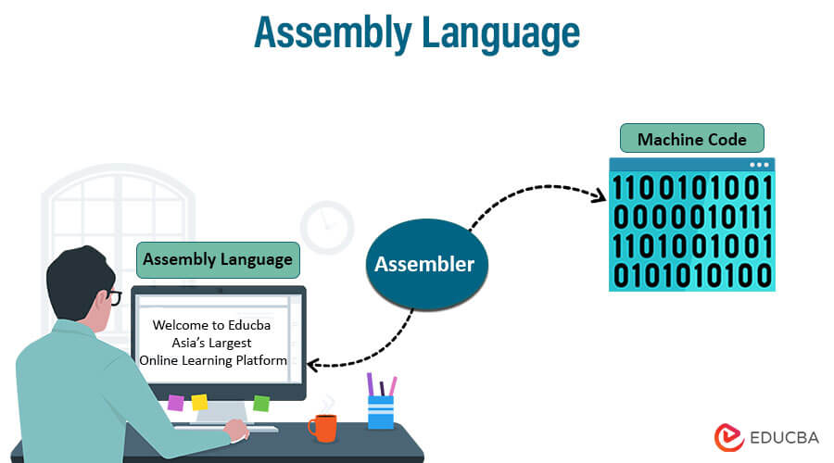
2️) Linker — Merging the Pieces
A linker takes multiple object files and glues them together into a final executable.
Why do we need it?
- Programs are often split into multiple files/modules
- Some parts (like libraries) come from external sources
- The linker resolves things like:
  - Function calls across files
  - Global variable references
  - External libraries
Input: .obj files
Output: .exe or .elf or .bin (platform-specific)
💡 Think of the linker as your program’s final assembler, stitching all parts into one runnable body.
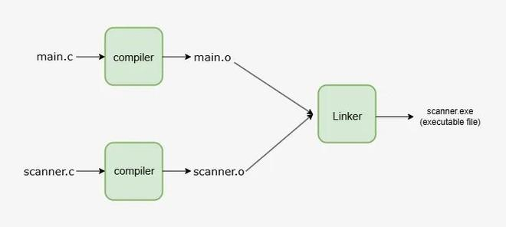

3️) Debugger — Your X-Ray Vision Tool
A debugger lets you:
- Pause your program at specific points (breakpoints)
- Step through code line-by-line
- Inspect registers, memory, variables, and the call stack
- Find the exact moment things go wrong

This is how pros figure out:
- Where segmentation faults happen
- Why a variable has a garbage value
- Whether a function even got called

Popular debuggers:
- gdb (GNU Debugger — Linux CLI)
- Visual Studio Debugger (GUI-based)
- WinDbg (Windows kernel-level debugging)
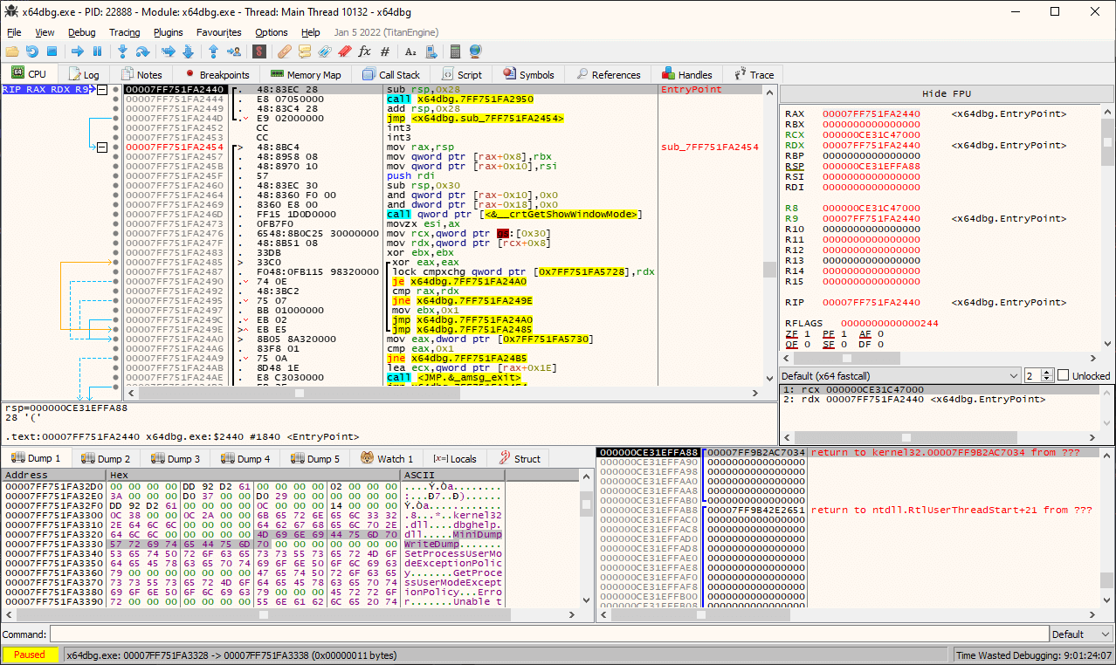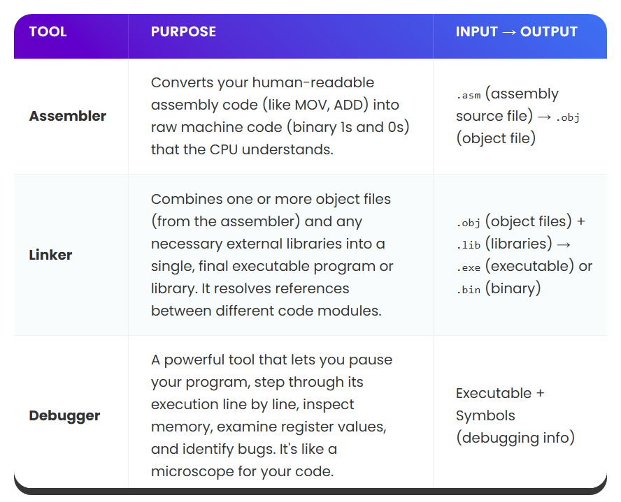
Yes — loaders are the last critical piece of the “code-to-execution pipeline” that most people skip.
If assemblers translate, linkers stitch, then loaders are the ones that launch the beast into RAM. Let’s plug that in and wrap this whole section up neatly before moving forward.

🧳 Loaders — The Final Step: Getting Code into Memory
🔄 What is a Loader?
A loader is a system-level program that takes your fully-linked executable (like .exe or .out) and loads it into RAM for execution.
Think of it like the valet:
You hand over the car keys (the executable), and the loader parks the program into memory, sets up the environment, and gives control to the CPU to start execution.

⚙️ What the Loader Actually Does:
- Reads the executable file: Loads headers, segments, and metadata.
- Allocates memory in RAM for code, data, and stack.
- Loads code & data sections into correct memory locations.
- Resolves runtime dynamic links (e.g. to shared DLLs or .so files).
- Sets up the stack, heap, and registers
- Starts execution by jumping to the program's entry point (usually main())
Without the loader, your code would just sit there in storage — not running, not alive.

Difference between linkers and loaders:
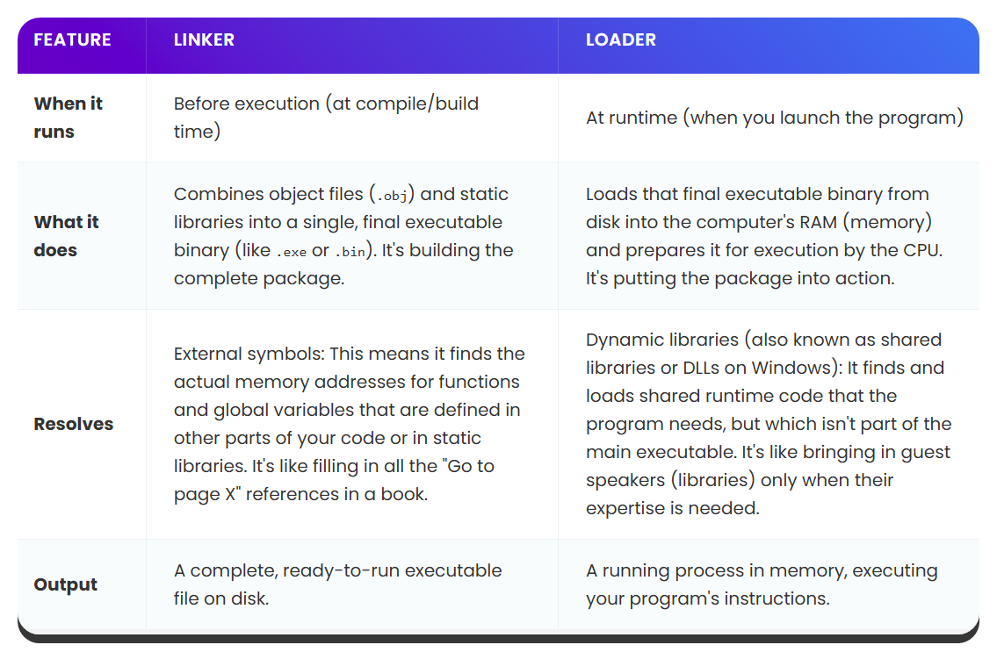
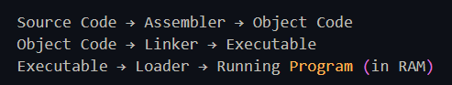
🧠 Why You Should Care as a Developer
- Knowing what the loader does helps you debug runtime crashes, missing DLLs, or initialization errors
- Low-level tools (like manual shellcode injection, OS dev, reverse engineering) rely heavily on manual loading
- Understanding the loader’s job clarifies how your .exe or .out goes from disk → memory → CPU
Alright, now that we’ve locked in the full pipeline from writing code to executing it, you’ve got the full picture:
Source code → Assembler → Linker → Loader → CPU runs it.
These tools give you deep control over the program, allowing for:
- Efficient code generation
- Tight memory usage
- Advanced debugging and reverse engineering

🗂️ FILE TYPES AND CPU MODES SUPPORTED BY MASM (MICROSOFT MACRO ASSEMBLER)
MASM creates different types of output files depending on the CPU mode your code is written for. These modes correspond to processor architectures (16-bit, 32-bit, and 64-bit) and affect how your assembly code is written and executed.
🔹 16-Bit Real-Address Mode
- Legacy mode used in DOS and embedded systems.
- Not supported on modern 64-bit Windows OS without emulators.
- Will only be covered in Chapters 14–17 for historical context.

🔹 32-Bit Protected Mode
- Supported by all 32-bit Windows OS versions.
- Easier to write and debug than 16-bit real mode.
- This is what most MASM tutorials use as the default.
🧠 We’ll refer to this as just “32-bit mode” from now on.

🔹 64-Bit Long Mode
- Runs on all 64-bit versions of Windows.
- Requires use of different registers (RAX, RBX, etc.) and calling conventions.
- MASM64 or x64 assembly tools are needed.

Let’s go deep on the above, I can’t leave my beginners hanging:
✅ Target: You’ll finally understand what MASM is, what it creates, what “CPU modes” even mean, and why it all matters when writing assembly code.
✅ No more guessing. No more reading the same paragraph 5 times like “wait huh?” 🤯

🔧 What is MASM?
MASM stands for Microsoft Macro Assembler.
It’s a program that takes your assembly code (with commands like mov eax, 1) and converts it into machine code — the raw binary instructions the CPU actually runs.
In other words:
- You write readable low-level code → MASM turns it into .obj (object) files or .exe (executable) files.
- This is just like how gcc compiles C code into machine code — but MASM does it for Assembly.
📁 What File Types Does MASM Create?
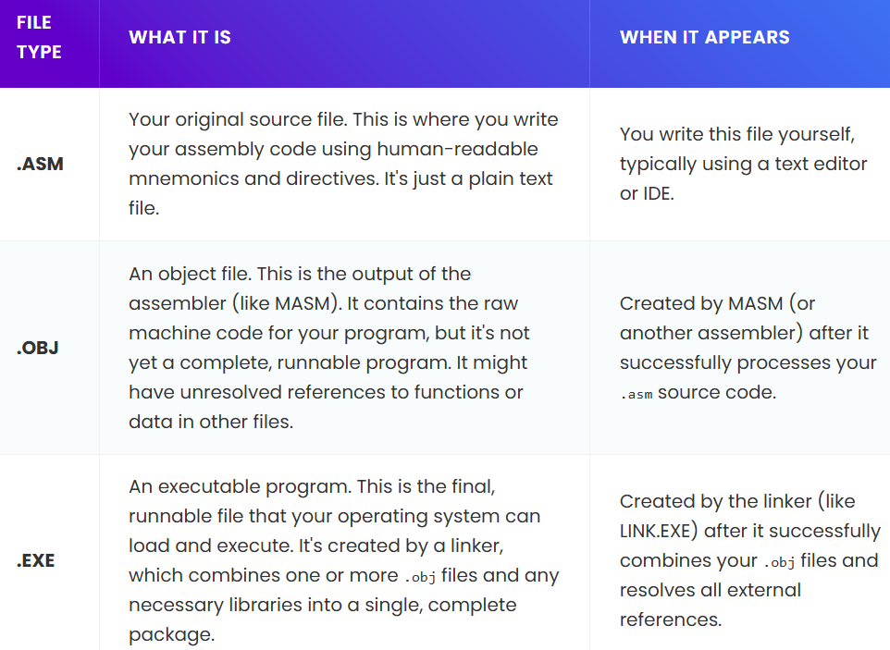
💡 Key takeaway: MASM (the assembler) only does the .ASM → .OBJ part. You need a separate tool called a linker (like LINK.EXE on Windows) to go from .OBJ → .EXE.

🧪 MASM vs Other Assemblers — They're All Translators
Let’s compare MASM to other assemblers:
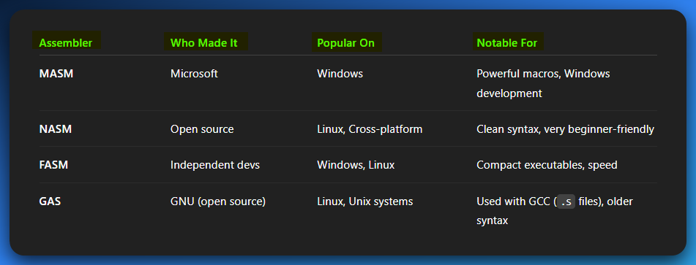
Full description in the html and the image.
They all convert assembly into machine code.
The only difference is syntax, platform, and ecosystem preferences.

💬 Think of it like this:
- MASM is like American English
- NASM is like British English
- GAS is like Shakespearean English
- FASM is like minimalist text-speak
They all say the same thing, just in slightly different dialects.

🧠 Why Should You Care Which One?
If you're targeting:
- Windows dev / WinAPI / legacy x86 tutorials ➜ MASM is your friend
- Cross-platform / Linux / modern low-level ➜ NASM or GAS is better
- Extreme performance & size optimization ➜ FASM might appeal to you
But the fundamentals of Assembly language don’t change — registers are registers, instructions are instructions, and you're still doing the same CPU-level work.

✅ You now fully understand:
- What MASM is
- What it produces
- How it compares to NASM/FASM/GAS
- Why it matters when choosing your tool

File Types Created by Assemblers: From Code to Executable
Assembly code doesn't run by itself. You write source code, then the assembler, linker, and maybe even other tools step in to create something the CPU can actually execute.
Let’s break it down — beginner-friendly, real-world style:

📝 .ASM — Your Source File
This is your code, written by you, in a human-readable format:
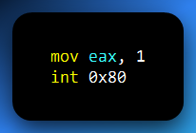
- It’s just plain text, like a .txt file.
- You write it using MASM, NASM, VSCode, etc.
- It’s not executable — it needs to be assembled.

⚙️ .OBJ — Object File (Assembled, But Not Ready Yet)
Think of .OBJ as a half-built car. The engine's in, but the wheels and doors aren’t connected yet.
- Created by the assembler from your .ASM file.
- Contains machine code — but some parts are still unresolved (like calls to external functions).
- Still not runnable — you need to link it.
Real analogy:
It's like you’ve prepped all your ingredients and chopped your veggies, but you haven’t cooked the dish yet.

🚀.EXE — Executable File (Ready to Run)
This is the final boss — the file you can actually double-click in Windows and watch it run.
- Created by a linker, not the assembler.
- Combines one or more .OBJ files + any required libraries (like Windows API).
- Links up external references (like printf, CreateFile, etc.).
- Adds sections like .text (code), .data (vars), .rdata (constants), etc.
Real analogy:
The linker takes all the car parts from .OBJ and builds a full car you can drive.

💾 .BIN — Raw Binary File (No Frills, No OS)
This is bare metal — a file that’s meant to be run without an OS.
- Just raw bytes — pure machine code, no headers or OS-specific structures.
- Often used in:
  - Bootloaders.
  - BIOS firmware.
  - Embedded devices (like Arduino, STM32).
- Doesn’t work like .EXE — it gets flashed to chips or run by a boot ROM.
Real analogy:
Imagine taking your machine code and tattooing it straight onto a CPU — no fancy packaging, no instructions.
A .BIN file is just raw data, with no extra formatting or system information.

🕵️ Why This Matters for Reverse Engineering
When you're reverse engineering, you’re usually handed a mysterious .EXE, .DLL, or .BIN.
Understanding how that file was built helps you know what you're dealing with:
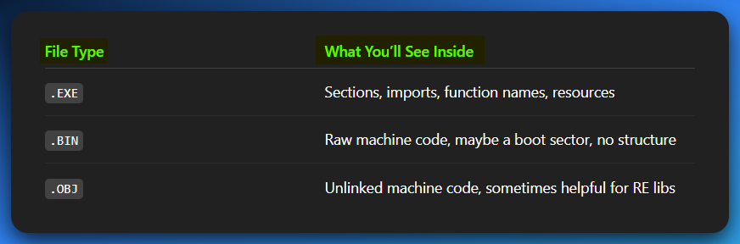
Knowing whether a file was created by MASM, GCC, or NASM also gives clues about calling conventions, section layouts, and symbol naming.
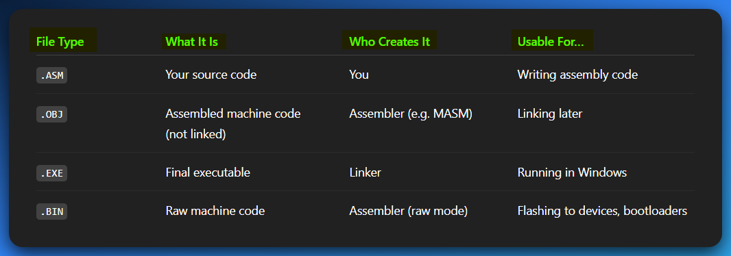
After you read this, I wanted to keep going on CPU modes, but damn! That topic is hot, I can’t just toss it in here, lets move to the next document.
We shall cover all the CPU-Modes addressed in the 007.MASM.FileTypes.Operation.Modes.confusion.removed.html document.

⚖️ Assembly Language vs. Machine Language
Let’s compare these two side-by-side:
Find the htmls or images file attached for a complete table of comparison.

🧠 Summary:
- Assembly = human-friendly representation of machine code
- Machine code = binary the CPU executes directly
- Assembly is easier to write, debug, and understand
- Machine language is harder to work with, but runs at maximum efficiency

💬 Final Thoughts:
- Writing machine code by hand is like writing in Morse code with no mistakes allowed.
- Writing assembly is like shorthand — better than Morse, but still not English.
- Use assembly when you need fine-tuned control, speed, or hardware access.
- Use a debugger and linker to manage and inspect the full system-level workflow.

Assembly gives you power and control, but also responsibility and danger.
High-level languages give you speed of development, maintainability, and portability.
In today’s world:
- Use high-level languages for most applications.
- Use assembly when you absolutely need performance or hardware control.
And now you understand why game engines, OS kernels, and malware authors still use this 40+ year-old beast. 💥

